William Eggleston
William Eggleston was born in Memphis, Tennessee and still lives there today. He attended 3 different colleges to study photography. University of Mississippi, Vanderbilt University and Delta State University. Growing up Eggleston was working in cotton fields, which was one of his first inspirations to start photography. The fields motivated him to shoot because he knew the fields so well and maybe he wanted to tell the story about working in cotton fields. The focus of William Eggleston’s work is to tell a story through his eyes and his photography. His work is very simple and straight to the point, so figuring out what he is shooting is not hard.
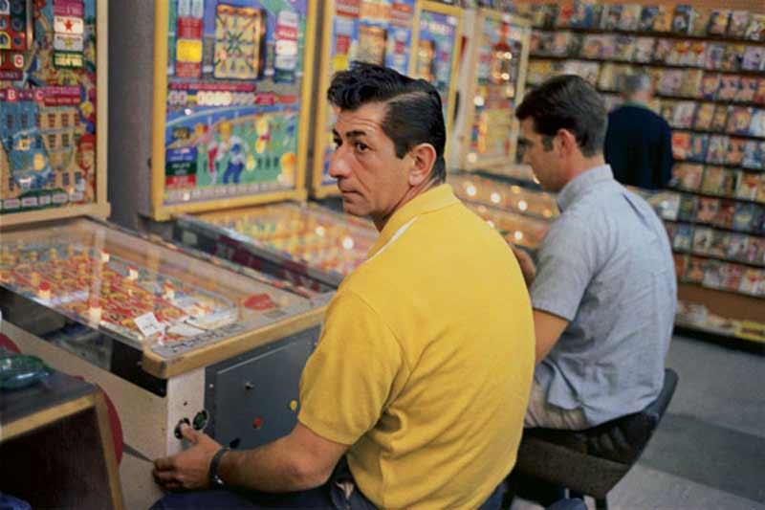
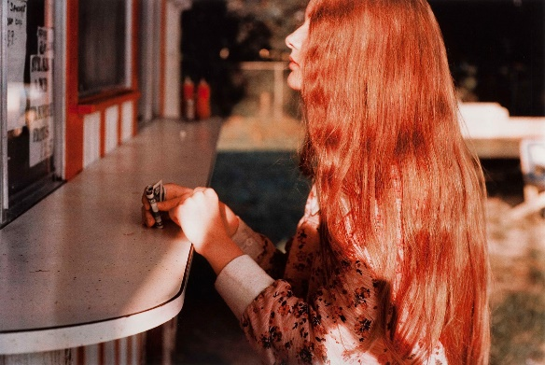

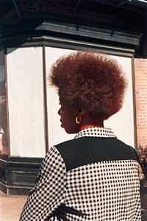
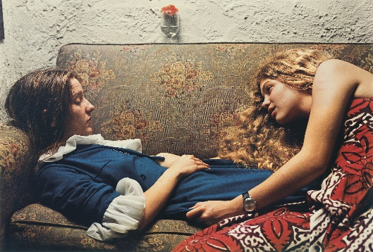
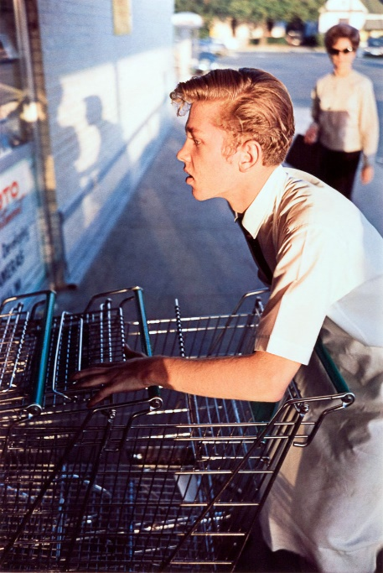

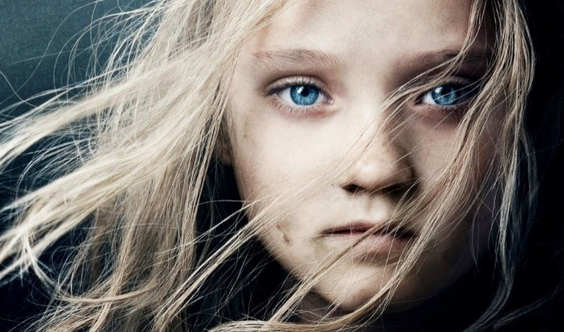
Annie Leibovitz
Annie Leibovitz was born on October 2, 1949 in Waterbury, CT. Leibovitz studied at the San Francisco Art institute. In 1970 she got a job at Rolling Stone and in 1983 she began working for the entertainment magazine, Vanity Fair. Most of her careers have to do with photography and taking photos. Her father’s passing was one of her main inspirations to keep working and keep doing what she loved. Leibovitz traveled to Japan with her mother in the summer after her sophomore year, and that was when she discovered her interest in taking photos. The focus of Leibovitz work is used for magazines and books like that.
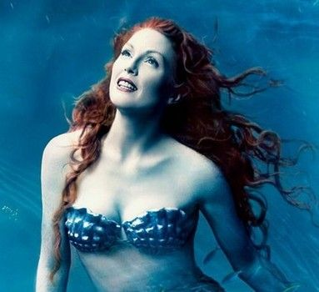
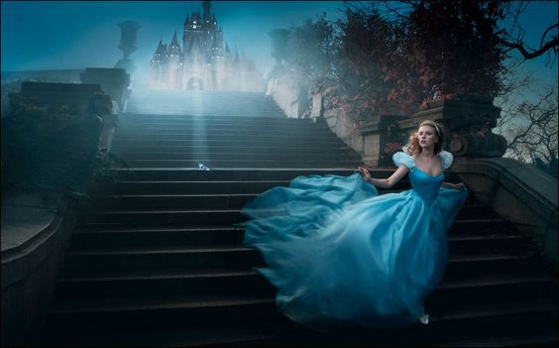
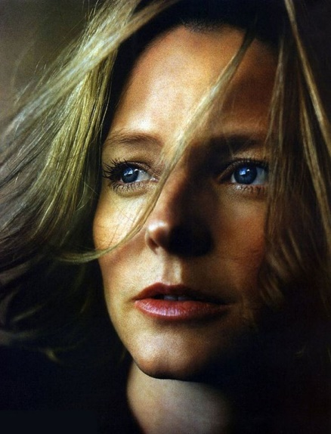
Dorothea Lange
Dorothea Lange is an American documentary photographer and photojournalist born on May 26, in 1895. She grew up in Hoboken, NJ in the period of social realism. Lange got an award, the “Guggenheim Fellowship for Creative Arts, US & Canada.” She died in October of 1965. In many of her photos, she showed farmers during the Great Depression working and showing how bad things were during the great depression. When she was 7, Dorothea contracted polio, and that illness was one of the many things that inspired her.

